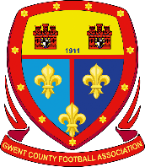 | THE GWENT COUNTY FOOTBALL ASSOCIATION  Referees Report of Misconduct Form -Player/Official
Each Report Form MUST be sent within 2 days of the occurrence to the:
Association Assistant Secretary Discipline: K.R. Jones.
Post: 39 Chester Close, Heolgerrig, Merthyr Tydfil, CF48 1SW1.
Email: kevin.jones@gwentfa.co.uk
Referees are advised to keep their statement below specific to the actual incident

Referees Name: | Click or tap here to enter text.
Home Club: | Click or tap here to enter text.
Away Club: | Click or tap here to enter text.
Played at: | Click or tap here to enter text.
League or Competition: | Click or tap here to enter text.
Date of Game: | Click or tap to enter a date.
Comet Round Number | Click or tap here to enter text.
Name of Player/Official Reported: | Click or tap here to enter text.
Comet ID: | Click or tap here to enter text.
Player/Officials Club: | Click or tap here to enter text.

Referees Statement:

Click or tap here to enter text.

